Lesson 24: Ellipses & Hyperbolas
Math 2412 Precalculus · Unit 4: Analytic Trigonometry, Conics & Discrete Topics · Student Guided Notes
Name: ______________________________ Date: ______________

Lesson objective
Students will define ellipses and hyperbolas by their foci, write their equations in standard form, graph them with their centers, vertices, co-vertices, foci, and asymptotes, rewrite general-form equations by completing the square, and solve an applied ellipse problem.

Before class
Complete these short tasks before the lesson. They review skills this lesson builds on.
- Complete the square: $4x^{2}−40x$ (factor out the 4 first) (Lesson 7).
- Find c if $c^{2}=64−25$, and if $c^{2}=36+4$; simplify the radicals.
- Find the slopes of the lines through the origin and the points (3, 5) and (3, −5).

Skill 24.1: Ellipses Centered at the Origin

Key ideas
- An ellipse is the set of all points whose distances to two fixed points add to a constant. Each fixed point is a ______________ (1) (plural: foci).
- The longer axis is the major axis, with the vertices at its ends; the shorter is the minor axis, with the co-vertices. The foci lie on the major axis.
- With $a>b>0$: the major axis has length 2a, the minor axis 2b, and the foci are c from the center, where ______________ (2).
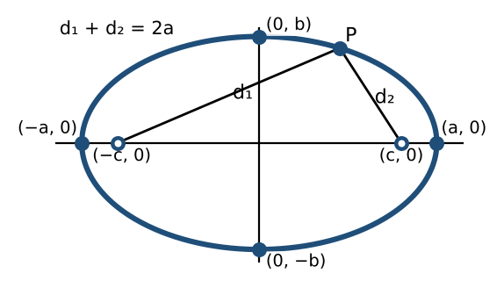
 | Major axis horizontal | Major axis vertical
Equation | $x^{2}/a^{2}+y^{2}/b^{2}=1$ | $x^{2}/b^{2}+y^{2}/a^{2}=1$
Vertices | (±a, 0) | ________ (3)
Co-vertices | (0, ±b) | (±b, 0)
Foci | ________ (4) | (0, ±c)

The larger denominator is $a^{2}$, and it sits under the variable of the major axis.

Example 1: write the equation
- Vertices (±8, 0), foci (±5, 0): horizontal, $a=8$, $c=5$, $b^{2}=64−25=39$. So $x^{2}/64+y^{2}/39=1$.
- Vertices (0, ±4), foci (0, ±√15): vertical, $a=4$, $c^{2}=15$, $b^{2}=16−15=1$. So the equation is ______________ (5).

Example 2: graph
- $x^{2}/9+y^{2}/25=1$: vertical, $a=5$, $b=3$, $c=4$. Vertices (0, ±5), co-vertices (±3, 0), foci (0, ±4).
- $x^{2}/36+y^{2}/4=1$: horizontal, $a=6$, $b=2$, $c=\sqrt{32}=4\sqrt{2}≈5.66$. Vertices (±6, 0), co-vertices (0, ±2), foci (±4√2, 0).
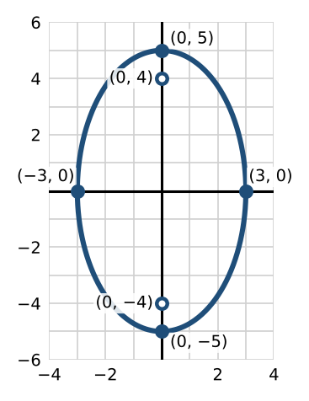 | 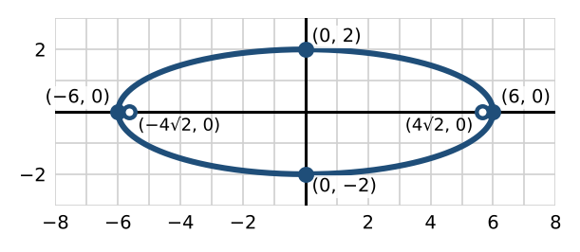

Practice
a. Write the equation of the ellipse with vertices (0, ±13) and foci (0, ±12).

Skill 24.2: Ellipses Centered at (h, k)

Key ideas
 | Major axis horizontal | Major axis vertical
Equation | ${(x−h)}^{2}/a^{2}+{(y−k)}^{2}/b^{2}=1$ | ${(x−h)}^{2}/b^{2}+{(y−k)}^{2}/a^{2}=1$
Vertices | (h ± a, k) | (h, k ± a)
Co-vertices | (h, k ± b) | ________ (6)
Foci | (h ± c, k) | ________ (7)

Example 1: vertices (−2, −8) and (−2, 2), foci (−2, −7) and (−2, 1)
The center is the midpoint, (−2, −3). The major axis is vertical with $a=5$ and $c=4$, so $b^{2}=25−16=9$: ${(x+2)}^{2}/9+{(y+3)}^{2}/25=1$.

Example 2: graph $4x^{2}+9y^{2}−40x+36y+100=0$
- Group and factor: $4(x^{2}−10x)+9(y^{2}+4y)=−100$.
- Complete the squares, adding $4·25$ and $9·4$ to both sides: $4{(x−5)}^{2}+9{(y+2)}^{2}=36$.
- Divide by 36: ${(x−5)}^{2}/9+{(y+2)}^{2}/4=1$. Center (5, −2), $a=3$, $b=2$, $c=\sqrt{5}$.
- Vertices (2, −2) and (8, −2); co-vertices (5, 0) and (5, −4); foci ______________ (8).
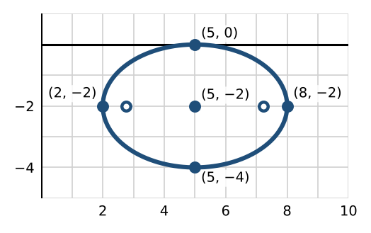

Example 3: the whispering gallery
Statuary Hall in the U.S. Capitol is an ellipse 96 feet long and 46 feet wide. Put the center at the origin with the long axis horizontal: $a=48$, $b=23$, so $x^{2}/2304+y^{2}/529=1$. Then $c=\sqrt{2304−529}=\sqrt{1775}≈42.13$, so two people standing at the foci are about ______________ (9) feet apart.

Practice
a. Graph ${(x+2)}^{2}/4+{(y−5)}^{2}/9=1$. Label the center, vertices, co-vertices, and foci.  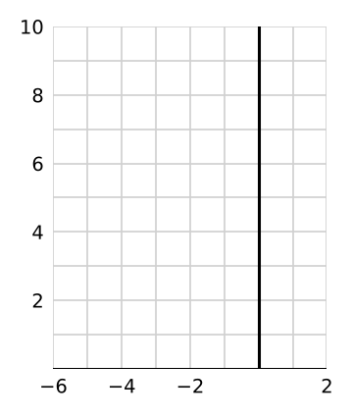 | b. Write $4x^{2}+y^{2}−24x+2y+21=0$ in standard form. Give the center, vertices, and foci.

Skill 24.3: Hyperbolas Centered at the Origin

Key ideas
- A hyperbola is the set of all points whose distances to two foci have a constant ______________ (10). It has two branches, mirror images of each other, formed when a plane cuts both halves of a double cone.
- The vertices are a from the center and the foci are c from the center, where ______________ (11). The branches approach two asymptotes.
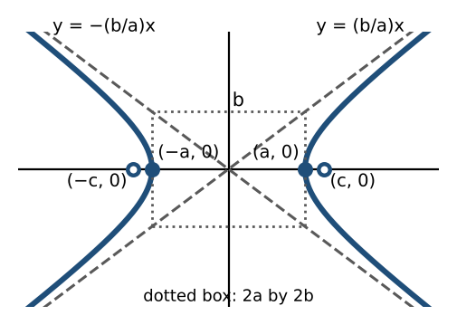
 | Opens left and right | Opens up and down
Equation | $x^{2}/a^{2}−y^{2}/b^{2}=1$ | $y^{2}/a^{2}−x^{2}/b^{2}=1$
Vertices | (±a, 0) | (0, ±a)
Foci | (±c, 0) | ________ (12)
Asymptotes | $y=±(\frac{b}{a})x$ | ________ (13)

Here $a^{2}$ is the denominator of the positive term, whether or not it is larger. To sketch, draw the rectangle $2a$ by $2b$ around the center, draw the asymptotes through its corners, then the branches from the vertices.

Example 1: graph
- $y^{2}/49−x^{2}/32=1$: opens up and down, $a=7$, $b=\sqrt{32}=4\sqrt{2}$, $c=\sqrt{81}=9$. Vertices (0, ±7), foci (0, ±9), asymptotes $y=±(\frac{7}{4\sqrt{2}})x=±(7\sqrt{2}/8)x$.
- $x^{2}/9−y^{2}/25=1$: opens left and right, $a=3$, $b=5$, $c=\sqrt{34}$. Vertices (±3, 0), foci (±√34, 0), asymptotes $y=±(\frac{5}{3})x$.
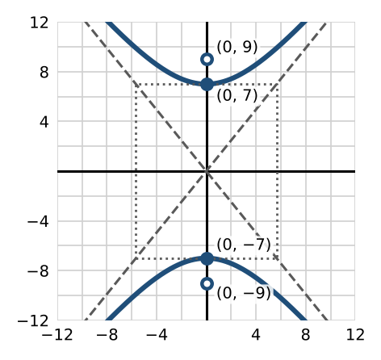 | 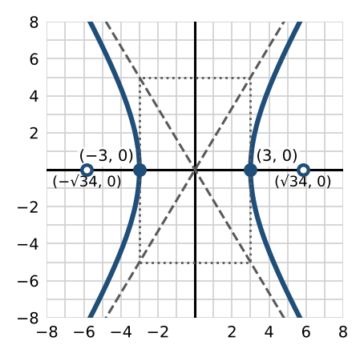

Example 2: write the equation
- Vertices (±6, 0), foci (±2√10, 0): $a=6$, $c^{2}=40$, $b^{2}=40−36=4$. So $x^{2}/36−y^{2}/4=1$.
- Vertices (0, ±2), foci (0, ±2√5): $a=2$, $c^{2}=20$, $b^{2}=16$. So the equation is ______________ (14).

Practice
a. Find the vertices, foci, and asymptotes of $y^{2}/64−x^{2}/36=1$.

Skill 24.4: Hyperbolas Centered at (h, k)

Key ideas
 | Opens left and right | Opens up and down
Equation | ${(x−h)}^{2}/a^{2}−{(y−k)}^{2}/b^{2}=1$ | ${(y−k)}^{2}/a^{2}−{(x−h)}^{2}/b^{2}=1$
Vertices | (h ± a, k) | (h, k ± a)
Foci | (h ± c, k) | (h, k ± c)
Asymptotes | $y−k=±(\frac{b}{a})(x−h)$ | ________ (15)

Example 1: write the equation
- Vertices (0, −2) and (6, −2), foci (−2, −2) and (8, −2): center (3, −2), $a=3$, $c=5$, $b^{2}=16$. So ${(x−3)}^{2}/9−{(y+2)}^{2}/16=1$.
- Vertices (1, −2) and (1, 8), foci (1, −10) and (1, 16): center (1, 3), $a=5$, $c=13$, $b^{2}=144$. So the equation is ______________ (16).

Example 2: graph ${(y−2)}^{2}/64−{(x+4)}^{2}/36=1$
Center (−4, 2), opening up and down; $a=8$, $b=6$, $c=10$. Vertices (−4, 10) and (−4, −6), foci (−4, 12) and (−4, −8), asymptotes $y−2=±(\frac{4}{3})(x+4)$.
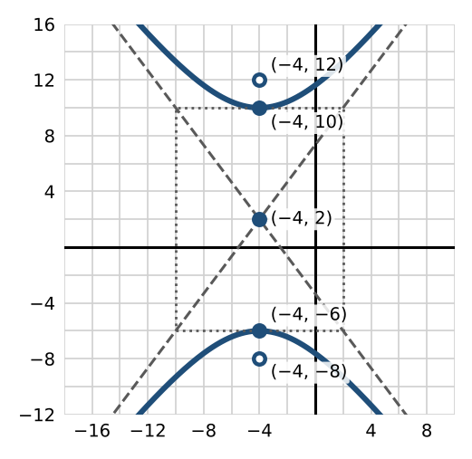

Practice
a. Write $9x^{2}−4y^{2}−36x−40y−388=0$ in standard form. Give the center, vertices, foci, and asymptotes, and graph it.
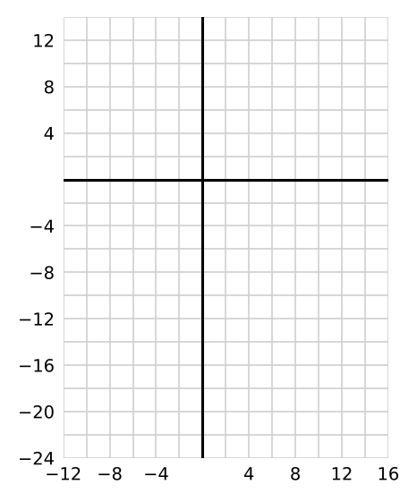

Exit check
1. Find the foci of $x^{2}/25+y^{2}/9=1$.

2. Find the asymptotes of $x^{2}/16−y^{2}/4=1$.

3. Is $4x^{2}−y^{2}+8x=0$ an ellipse or a hyperbola? How can you tell?

